|  |  |  |  |
| --- | --- | --- | --- |
| |  |  | | --- | --- | | **Logo_FPT_University_doc** | **MINISTRY OF EDUCATION AND TRAINING** |   **FPT UNIVERSITY**   |  | | --- | | Capstone Project | |
|  |
| Cooking recipes sharing website  Report 6: Software User’s Manual |
| |  |  | | --- | --- | | **Master Chefs team** | | | **Group Members** | Trần Trung Kiên - 01017  Đặng Xuân Toàn - 01143  Trần Sỹ Tùng - 01302  Bùi Trung Kiên - 01359  Ngô Thị Việt Anh - 01286 | | **Supervisor** | Huỳnh Anh Dũng | | **Ext Supervisor** | Nguyễn Tất Trung | | **Capstone Project code** | CRS\_v1.0 | |
|  |

- Hanoi, 8/2012 –

**Record of Changes**

|  |  |  |  |  |
| --- | --- | --- | --- | --- |
| **Date** | **Change Item** | **Description** | **By** | **Version** |
| 15/08/2012 | All | Create the document | TungTS | 0.1 |
| 16/08/2012 | All | Edit format document | ToanDX | 1.0 |

Contents

[I. Installation Guide 4](#_Toc333043279)

[1. Setting up the environment at server side 4](#_Toc333043280)

[2. Deployment at server side 4](#_Toc333043281)

[2.1 Prepare deployment package 4](#_Toc333043282)

[2.2 Deploy Database 4](#_Toc333043283)

[2.3 Deploy web application 7](#_Toc333043284)

[2.4 Change Configurations 11](#_Toc333043285)

[II. User’s Guide 12](#_Toc333043286)

[1. Register 12](#_Toc333043287)

[2. Login 13](#_Toc333043288)

[3. Forgot Password 14](#_Toc333043289)

[4. View Profile 15](#_Toc333043290)

[a. Method 1 15](#_Toc333043291)

[b. Method 2 15](#_Toc333043292)

[5. Menu bar 16](#_Toc333043293)

[6. Sort bar 17](#_Toc333043294)

[a. Recipes 17](#_Toc333043295)

[b. News 17](#_Toc333043296)

[c. Tips 17](#_Toc333043297)

[7. View detail 17](#_Toc333043298)

[a. Recipe 18](#_Toc333043299)

[b. Tips 21](#_Toc333043300)

[c. Question/Answer 22](#_Toc333043301)

[8. Search 23](#_Toc333043302)

[9. Right Menu 24](#_Toc333043303)

[10. Create 25](#_Toc333043304)

[11. Dictionary 27](#_Toc333043305)

[III. Administrator’s Guide 30](#_Toc333043306)

[1. Manage Contents 30](#_Toc333043307)

[2. Manage Spam 32](#_Toc333043308)

[a. Manage User 33](#_Toc333043309)

[b. Manage Roles 35](#_Toc333043310)

[4. Categories 37](#_Toc333043311)

[a. Manage Tip Categories & Recipe Categories 38](#_Toc333043312)

[b. Create new Tip & Recipe categories 39](#_Toc333043313)

[c. Manage Small Recipe category 39](#_Toc333043314)

[d. Create Small Recipe Categories 40](#_Toc333043315)

[5. Approval 41](#_Toc333043316)

[a. Approve recipes 41](#_Toc333043317)

[b. Unapprove recipes. 42](#_Toc333043318)

[6. Dictionary 42](#_Toc333043319)

# Installation Guide

## Setting up the environment at server side

The following software must be installed into the server machine:

* Windows Server 2008 operating system
* Internet Information Services (IIS) 7.5
* SQL Server 2008 R2
* .NET Framework 4.0

## Deployment at server side

### Prepare deployment package

* Extract the deployment package to a folder on the server
* For example: D:\Temp\CRS\_Deployment\_Package

### Deploy Database

* Open Microsoft SQL Server Management Studio (SSMS)
* Create a database named CRS

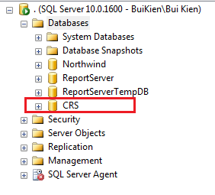

* Open file <deployment\_package>\Database\Schemas\Database Schemal.sql in SSMS
* Change working database in SSMS to CRS

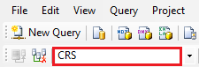

* Press F5 to run the script. Data tables should be created for CRS database

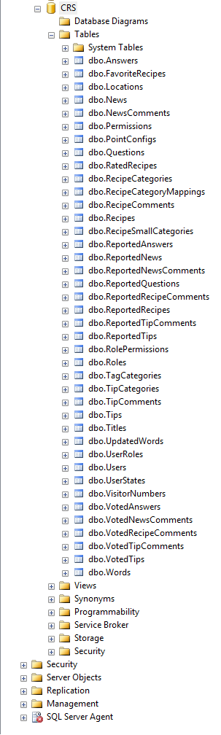

* Open file <deployment\_package>\Database\Data\CRS\_Reference data.sql in SSMS
* Press F5 to run the script. Reference data should be inserted to CRS database. For example the following is data of Permissions table:

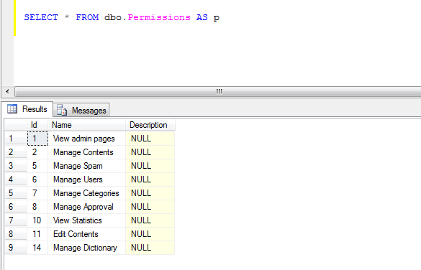

* The database contains one user with login account: kientt/19001789. This user has full privileges to the system.

### Deploy web application

* Register ASP.NET with IIS: open command line tool with admin privilege, change working folder to C:\Windows\Microsoft.NET\Framework64\v4.0.30319

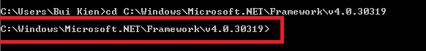

* Type aspnet\_regiis –i and press enter to register ASP.NET 4.0 to IIS

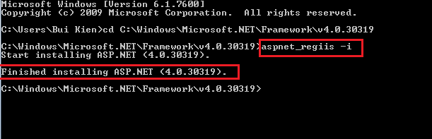

* Open IIS by opening start menu, type iis and press enter

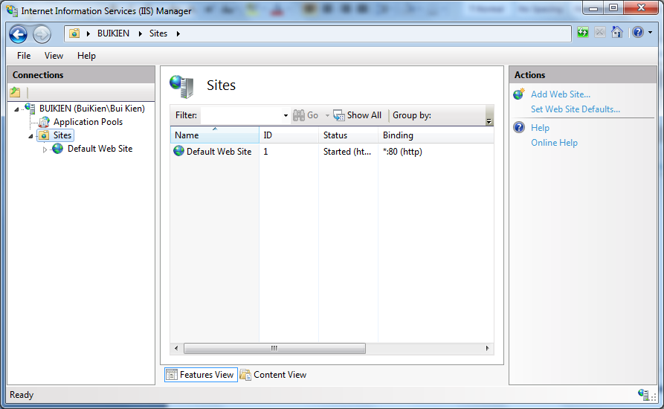

* Select Application Pools menu on the left menu bar, then select DefaultAppPool, click on Advanced Settings menu on the right bar, then open Identity window, choose Built-in account as LocalSystem:

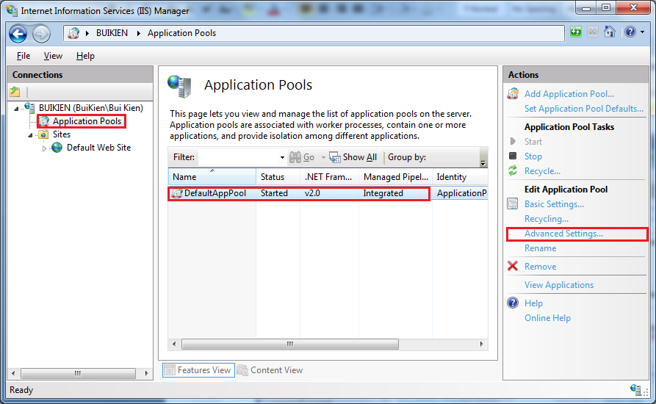

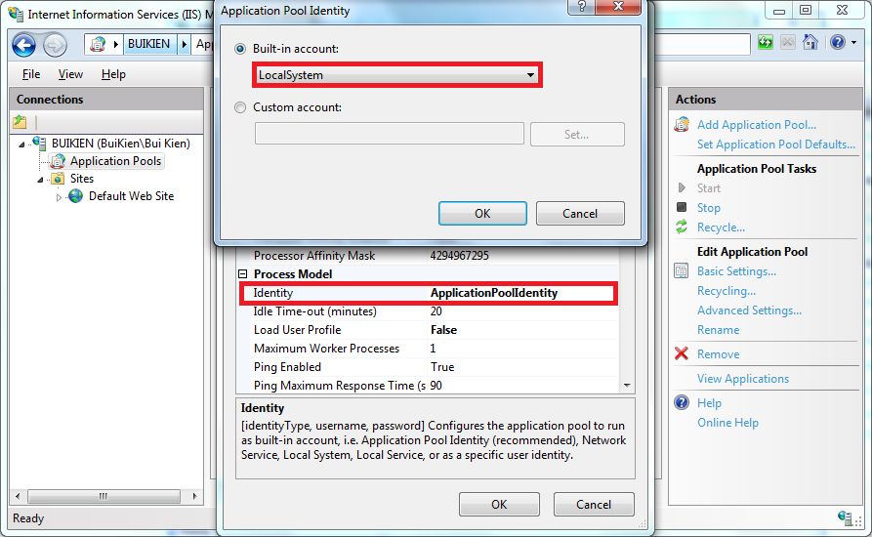

* Copy contents of<deployment\_package>\Web folder to another working folder. This folder will be the physical path of the web app. For example: E:\Study\CRS\CRS.Web

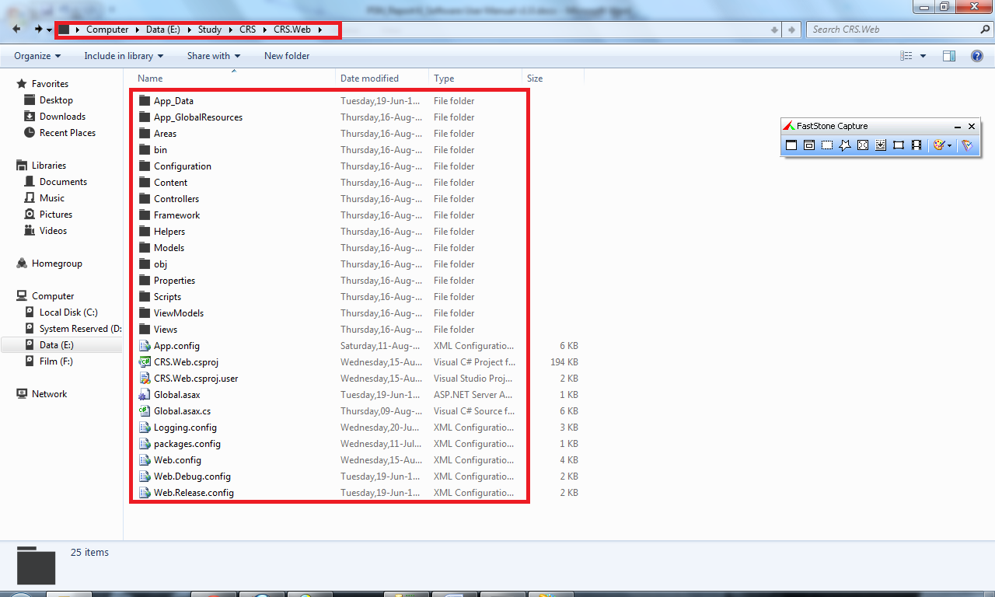

* Test the application by entering localhost/crs/ in to address bar of the browser. The application should show up:

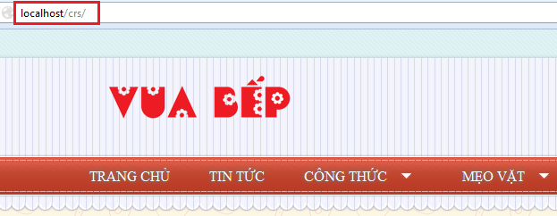

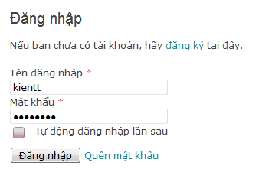

### 2.4 Change Configurations

#### 2.4.1 Change logging config

* Open file Logging.config in the application physical path
* Change the log files for errors and general to an absolute file path or relative file path to the application

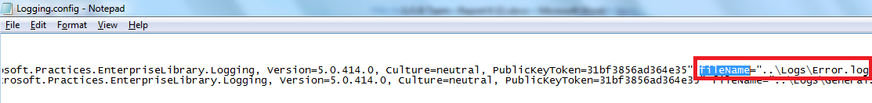

#### 2.4.2 Change system config

* Open file AppSettings.config in the application physical path

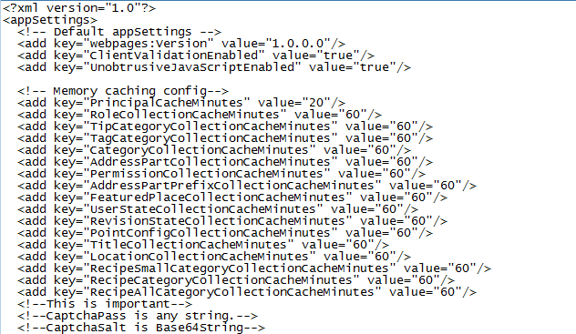

* Change config values appropriately

# User’s Guide

## Register

dangki1.PNG

* Click mouse to “Đăng ký thành viên” hyperlink.

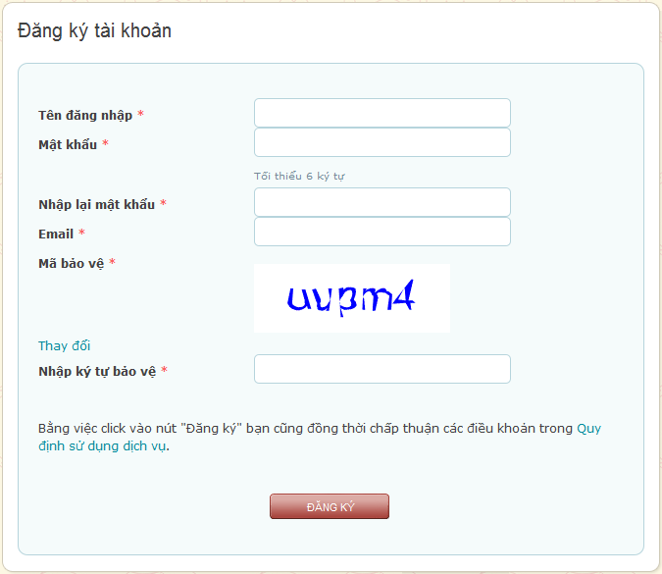

* Fill all required information

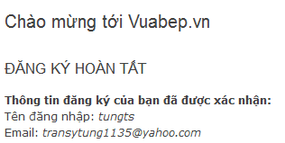

* Successful message will be displayed.

## Login

dangki1.PNG

* Click mouse to “Đăng nhập” hyperlink.

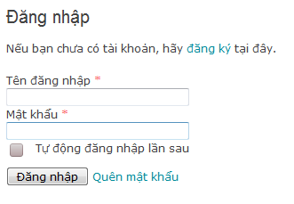

* Enter user account and password correctly and then click to “Đăng nhập” button. If you want browser will automatically login in the next time.

## Forgot Password



* If user is already has an account but forgets password. User can click to “Quên mật khẩu” hyperlink.

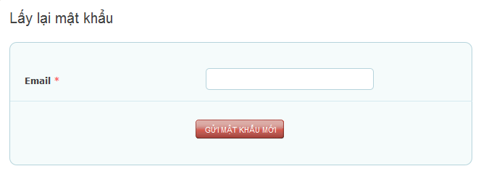

* Enter user’s account email and then click to “Gửi mật khẩu mới”. System will send to user a new password to email.

## View Profile

### Method 1

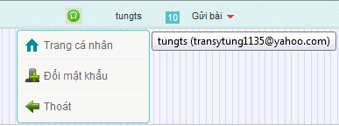

* Click to username and then click to “Trang cá nhân” hyperlink

### Method 2

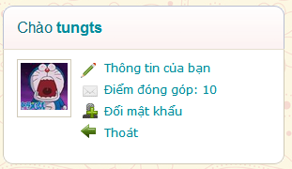

* Click to “Thông tin của bạn” hyperlink on the right of website.

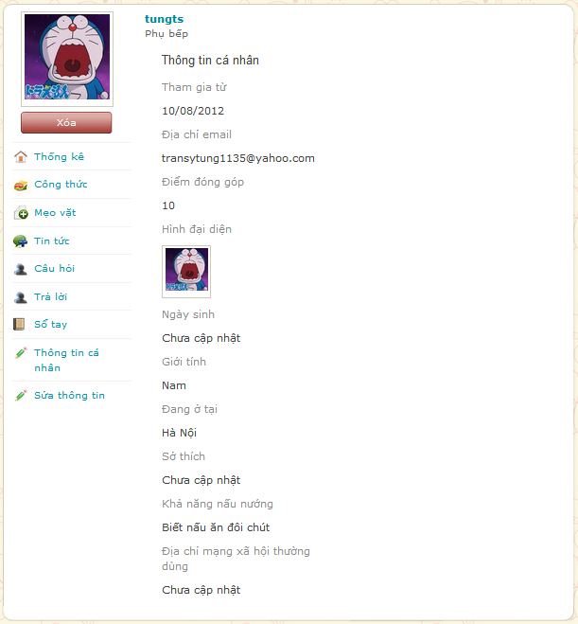

* Thông kê: Statistic your contribution.
* Công thức, mẹo vặt, tin tức, câu hỏi and trả lời: View your contribution in each category and include hyperlink to navigate to corresponding contribution.
* Sổ tay: View your favorite contents were added by you.
* Sửa thông tin: Edit your information

## Menu bar

C:\Users\Bui Kien\Downloads\Menubar_1.PNG

* Menu bar contains hyperlinks to main function such as “Trang chủ”, “Tin tức”, “Công thức”, “Mẹo vặt”, “Hỏi đáp”, Tìm kiếm”.

**admin.PNG**

* And if user is Admin or Power User, menu bar has “Admin” hyperlink.

## Sort bar

C:\Users\Bui Kien\Downloads\Menubar_1.PNG

## Recipes

* Click to “Công thức” hyper link.

C:\Users\Bui Kien\Downloads\SortBar_2.PNG

* Mới nhất: Sort by the newest recipes are posted.
* Lượt xem: Sort by the most view recipes
* Bình luận: Sort by the most comment recipes.
* Đánh giá: Sort by user’s rating.
* Chứng nhận: Sort by approved recipes by cooking experts.

## News

* Click to “Tin tức” hyperlink

C:\Users\Bui Kien\Downloads\SortBar_1.PNG

* Mới nhất: Sort by the newest news is posted.
* Lượt xem: Sort by the most view news
* Bình luận: Sort by the most comment news.

## Tips

* Click to “Mẹo vặt” hyper link

C:\Users\Bui Kien\Downloads\SortBar_3.PNG

* Mới nhất: Sort by the newest tips are posted.
* Lượt xem: Sort by the most view tips
* Bình luận: Sort by the most comment tips.
* Bình chọn: Sort by user’s rating

## View detail

### Recipe

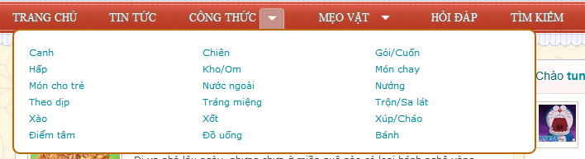

* Click to arrow beside “Công thức” hyper link to show categories of recipes.

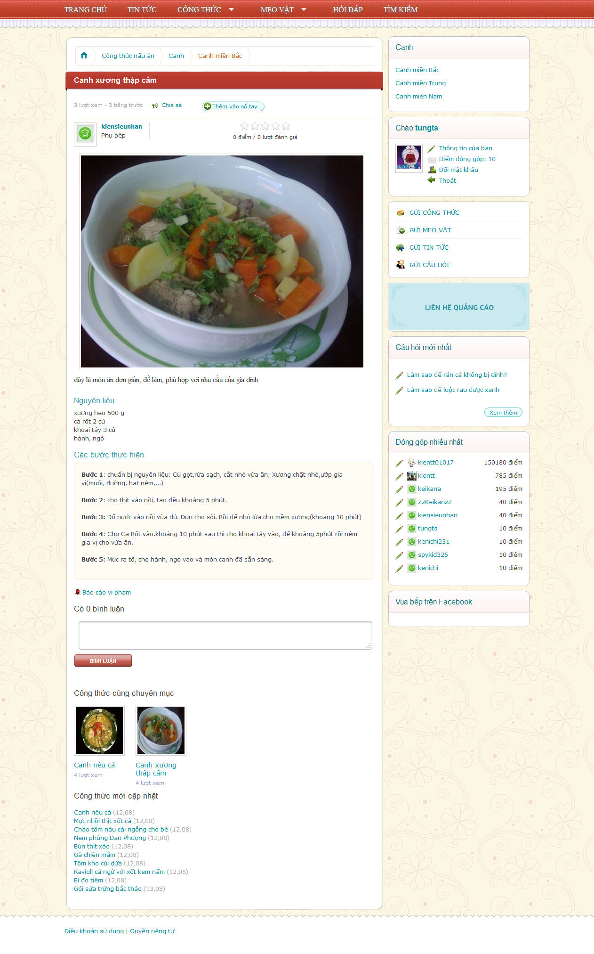

* Chia sẻ: Click to “Chia sẻ”



* Click to social network user want to share.
* Rating bar: Click to star (1->5) to rate for this recipe.

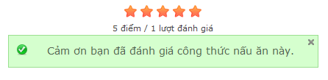

* Click to “Like” button to share user’s like on Facebook.
* Click to “G+” button to share user like on Google+
* Click to “Thêm vào sổ tay” to add this recipe to “Sổ tay”.
* Click to “Bình luận” textbox to leave a comment and then click to “Bình luận” button to post comment

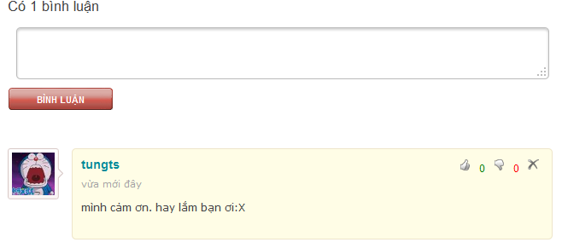

* Click thumb up or thumb down button to rate comment (you can’t rate your own comment). Click “X” button to delete.

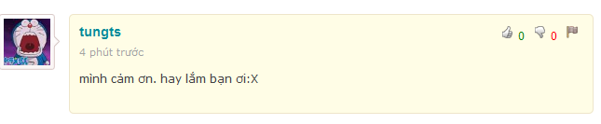

* Click “Flag” button to report if this comment has bad content or spam.

### Tips

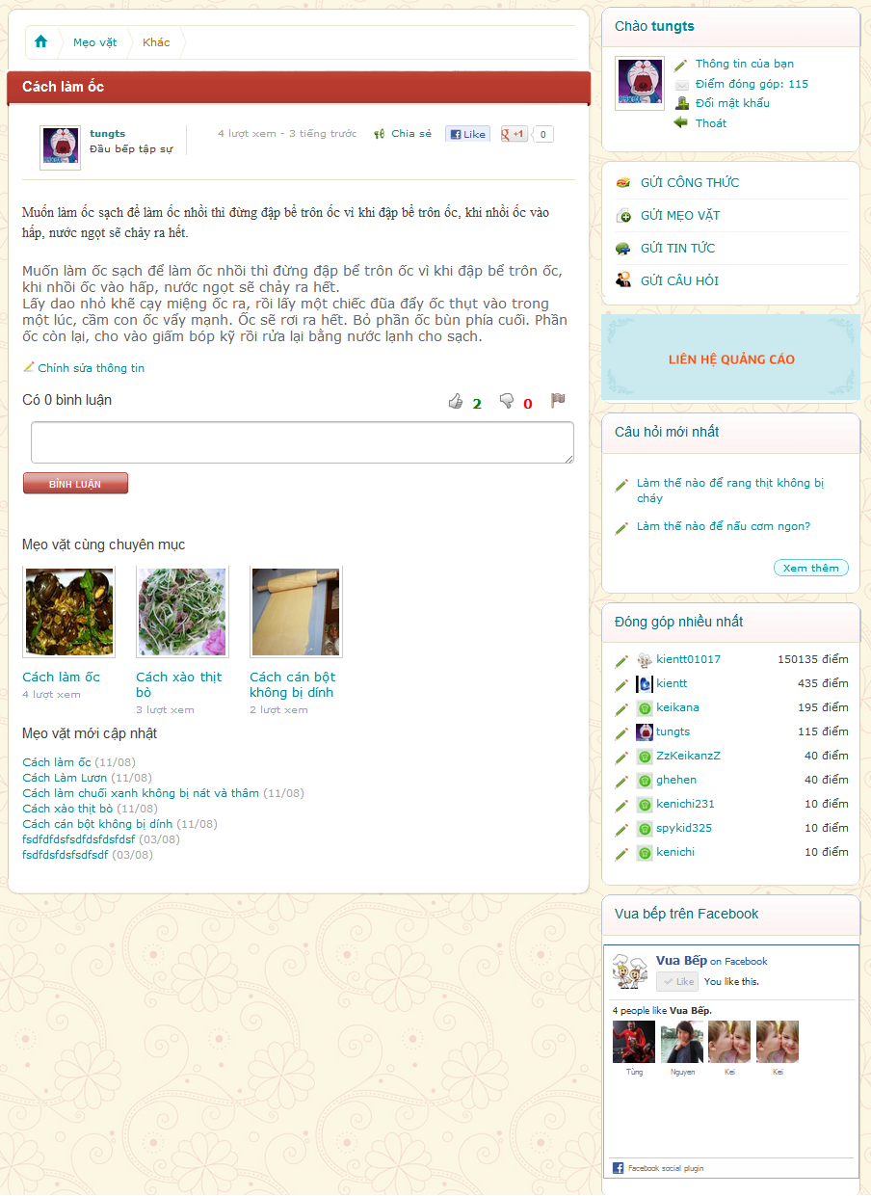



* Click thumb up or thumb down button to rate comment (you can’t rate your own comment). Click “X” button to delete.



* Click “Flag” button to report if this comment has bad content or spam.

### Question/Answer

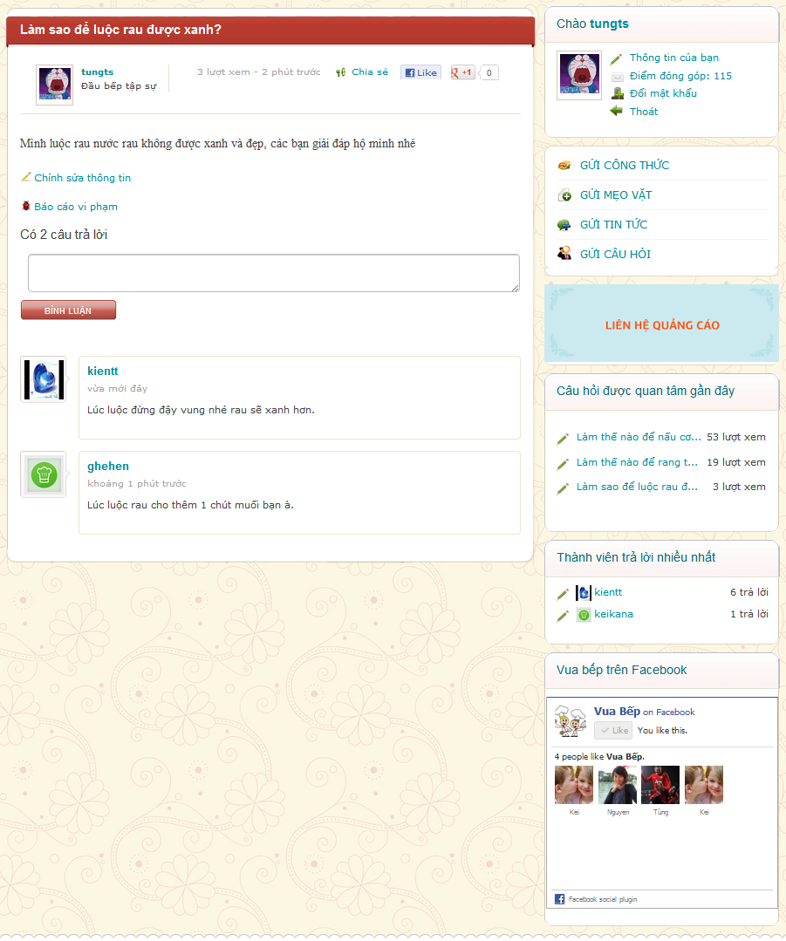

## Search

C:\Users\Bui Kien\Downloads\Menubar_1.PNG

* Click to “Tìm kiếm” hyperlink on menu bar

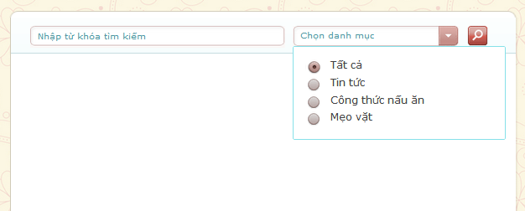

* User enters keyword and then click to “Chọn danh mục” dropdown list choose category to search. After that, user clicks to search icon to search.

## Right Menu

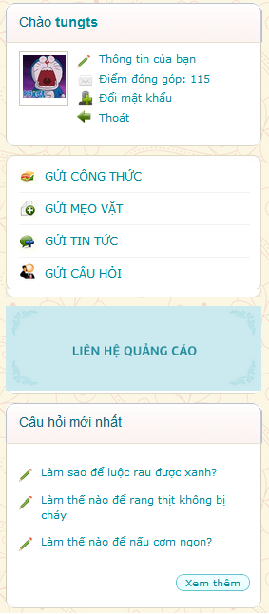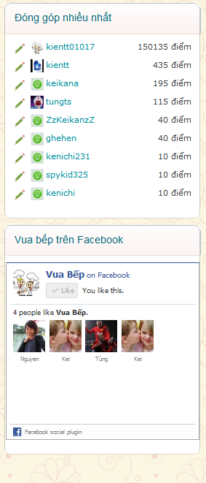

* Right menu contain user menu, create menu, banner, latest question, top user and facebook plugin.
* User can use hyperlink at right menu to quick access.

## Create

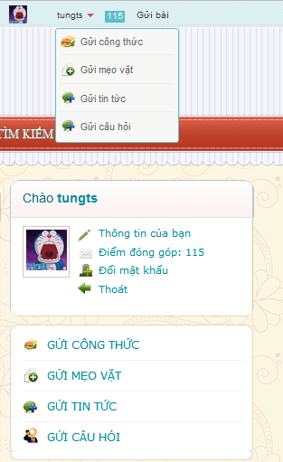

* User has two ways to access create function.
* Click to “Gửi công thức” to create new recipe

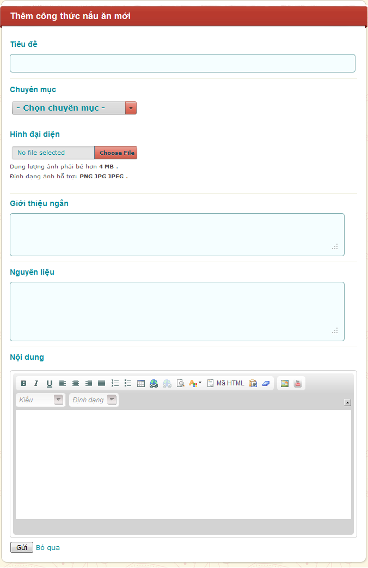

* Click to “Chọn chuyên mục” drop down list to choose category for recipe .Click to “Choose file” button to choose image from user’s computer.
* Fill all information and then click to “Gửi” button to create or “Bỏ qua” to cancel.
* Create function is the same for “Gửi mẹo vặt” and “Gửi tin tức”.
* Click to “Gửi câu hỏi” hyperlink.

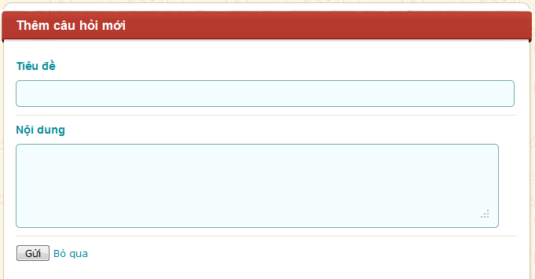

* Fill all information and then click to “Gửi” button to submit or “Bỏ qua” hyperlink to dismiss.

## Dictionary

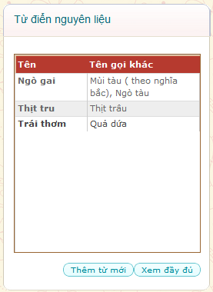

* Click to “Xem đầy đủ” to view full list of word

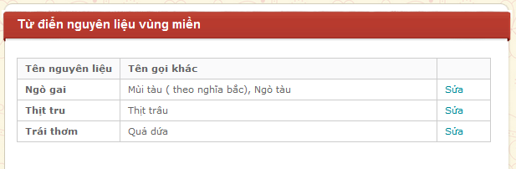

* Click to “Sửa” to edit word

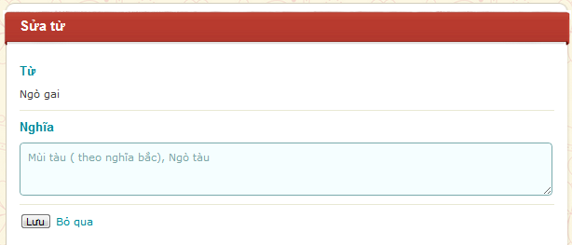

* Edit in “Nghĩa” textbox and then click to “Lưu” button to save or “Bỏ qua” hyperlink to dismiss.



* Click to “Thêm từ mới” button to create new word.

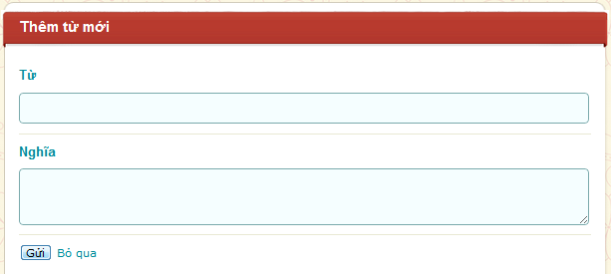

* Fill all information and then click to “Gửi” button to send or “Bỏ qua” hyperlink to dismiss



* When user in “Xem đầy đủ” page. Use “Ctrl + F” on keyboard to open search function of web browser.

search1.PNG

Or

search2.PNG

* Will appear, user can type to search word.

# Administrator’s Guide

Click to “Admin” hyperlink on Menu bar

admin.PNG

## Manage Contents

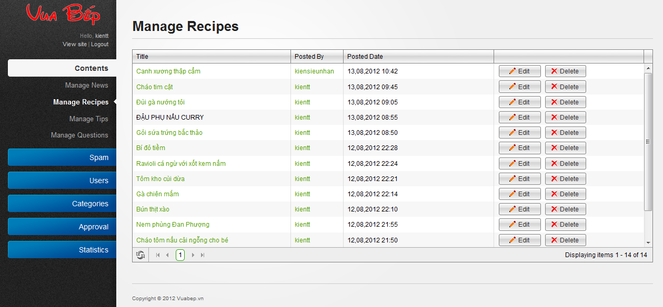

* Click to “Edit” button, system will navigate admin to edit content

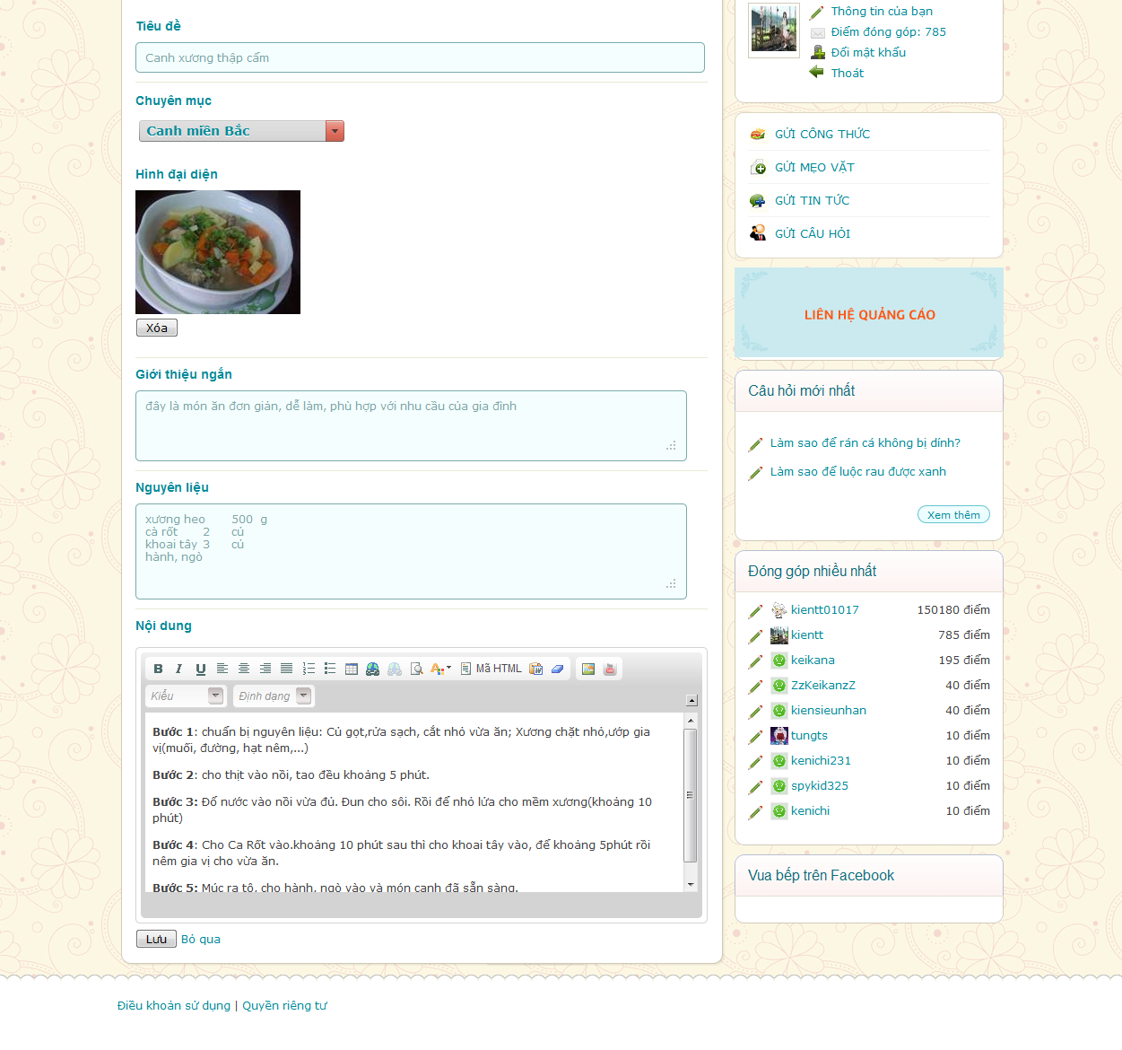

* After edit content, click to “Lưu” button to save.
* Click to “Delete” button to delete this content, system will ask to confirm.

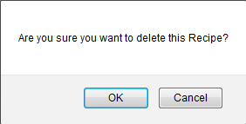

* Click “OK” button to delete this content, click “Cancel” to back to manage contents page.

## Manage Spam

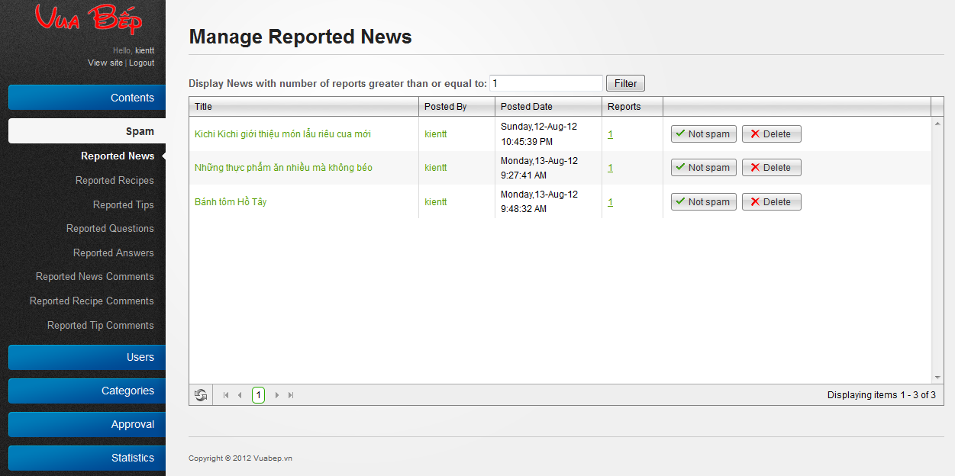

* Click to Spam to show sub-menu.
* Click “Reported” to view reported content and then click to “Not spam” button to delete this report.
* Click to “Delete” button, system will ask to confirm.



* Click “OK” button to delete this content, click “Cancel” to back to manage contents page.

1. **User**

### Manage User

**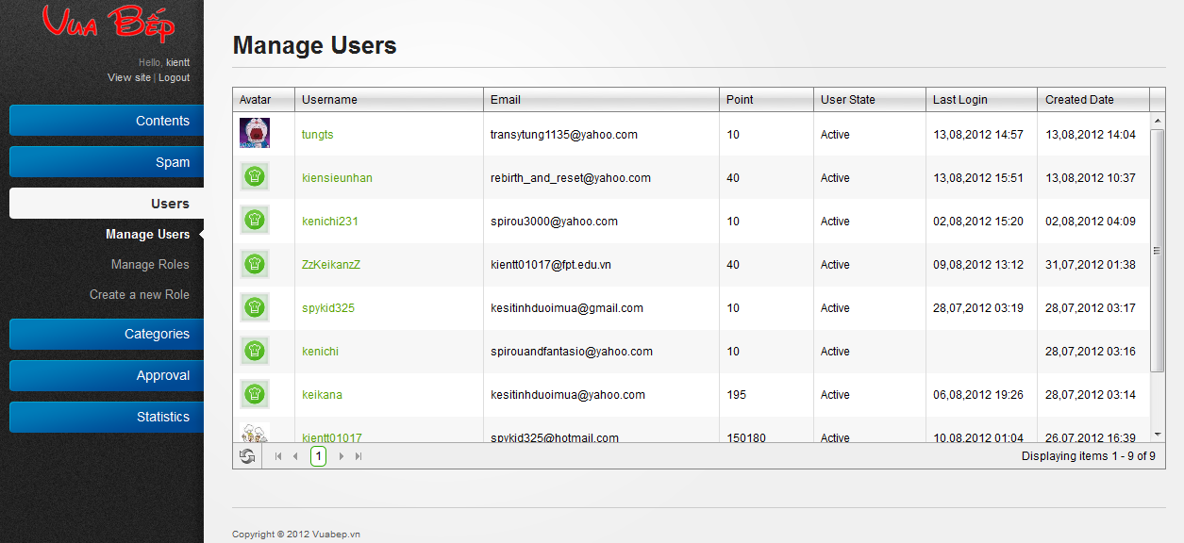**

* Click to username to edit or delete user.

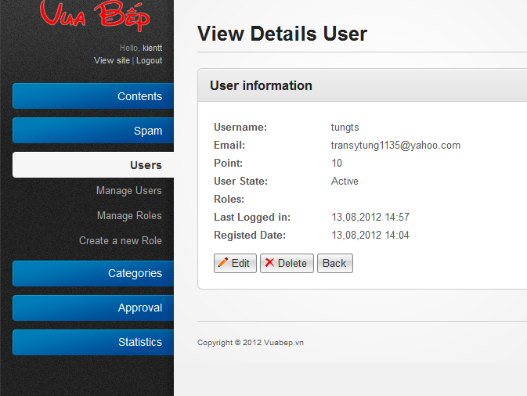

* Click “Edit” button to edit user information

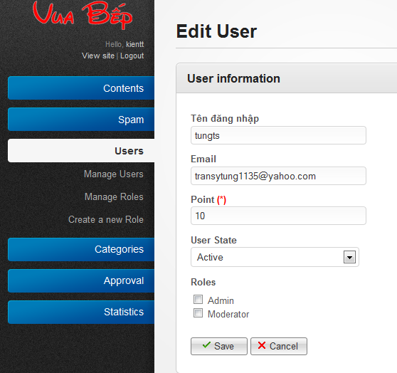

* Click to “Save” button to save. Click to “Cancel” to back to previous page.

### Manage Roles

**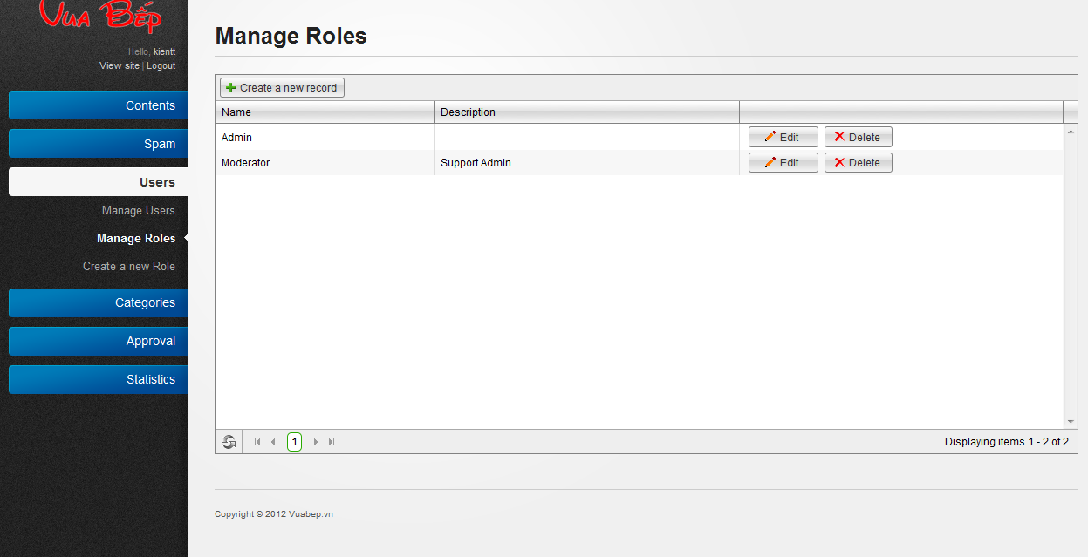**

* Click to “Create a new record” to create new role.

**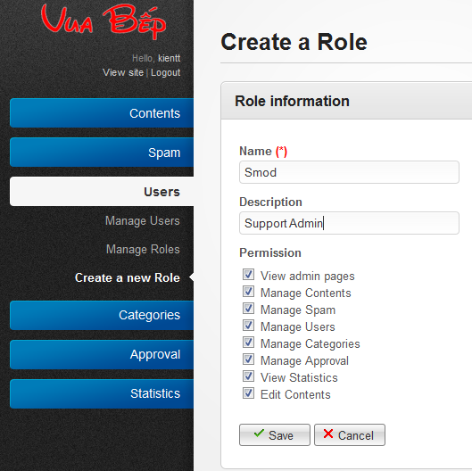**

* Click to “Save” button to save new record.

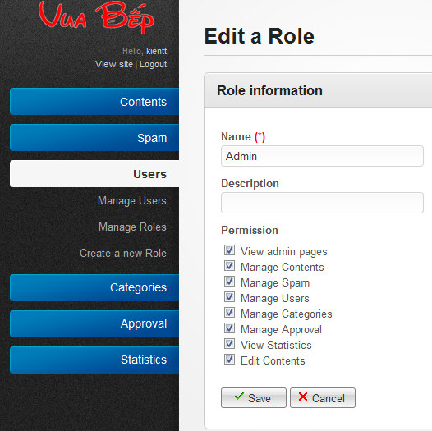

* Click to “Edit” button to edit role and then click to “Save” button to save.
* Click to “Delete” button to delete record.

## Categories

1. Manage Tip Categories & Recipe Categories**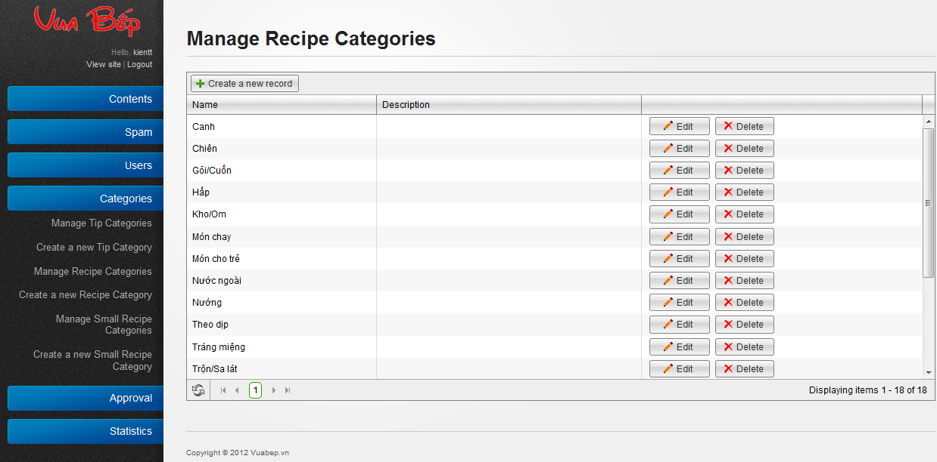**

* Manage Tip Categories, Manage Recipe Categories are show all each categories.
* Click to “Delete” button to delete a category.
* Click to “Edit” button to edit a category.

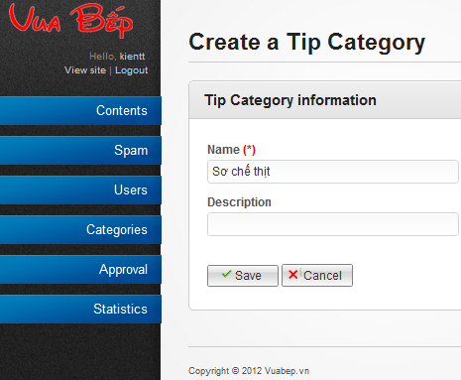

* Edit content of category and then click “Save” button to save or “Cancel” button to dismiss.

### Create new Tip & Recipe categories

* Click to “Add new record” button to create new category.

2.PNG

* Fill information and then click to “Save” button to save or “Cancel” to dismiss.

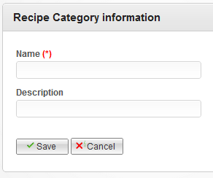

### Manage Small Recipe category

**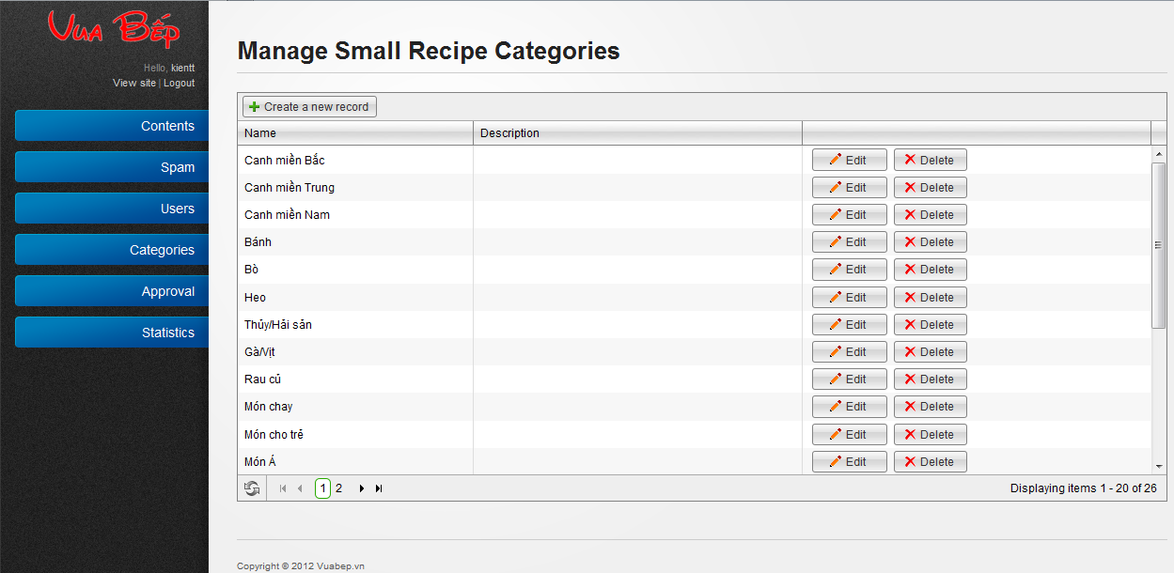**

* Click to “Delete” button to delete a category.
* Click to “Edit” button to edit a category.

**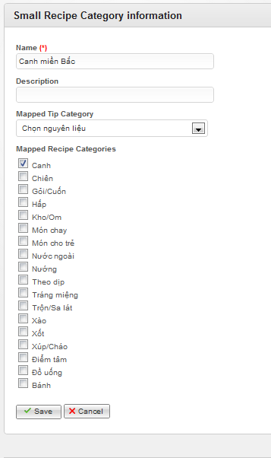**

* Edit information and then click “Save” button to save or “Cancel” button to dismiss.

### Create Small Recipe Categories

* Click to “Add new record” button to create new category.

2.PNG

* Fill information and then click to “Save” button to save or “Cancel” to dismiss.

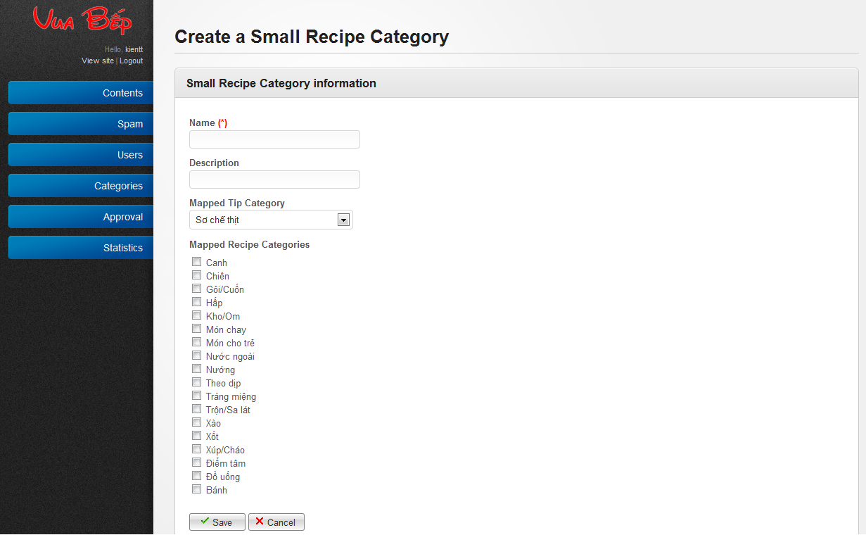

## Approval

### Approve recipes

**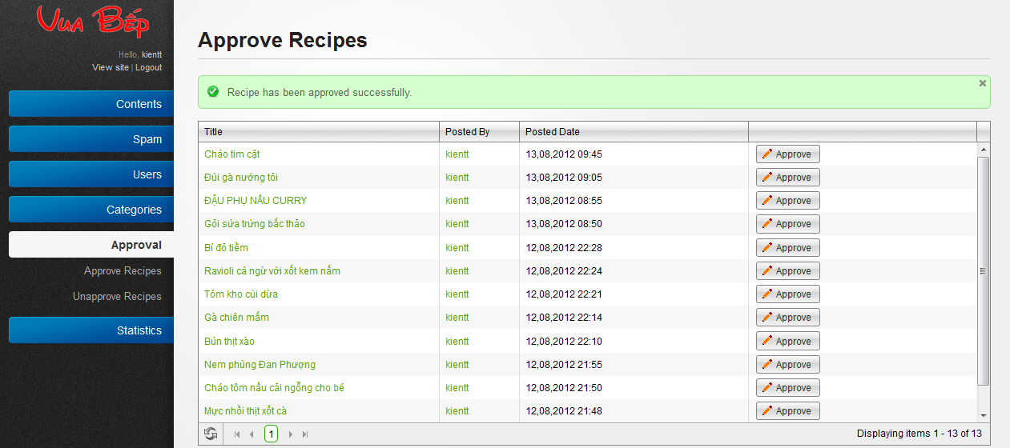**

* Click to “Approve” to approve a recipe.

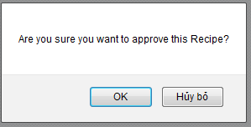

* Click “Ok” button to complete action or “Hủy bỏ” button to dismiss.

### Unapprove recipes.

**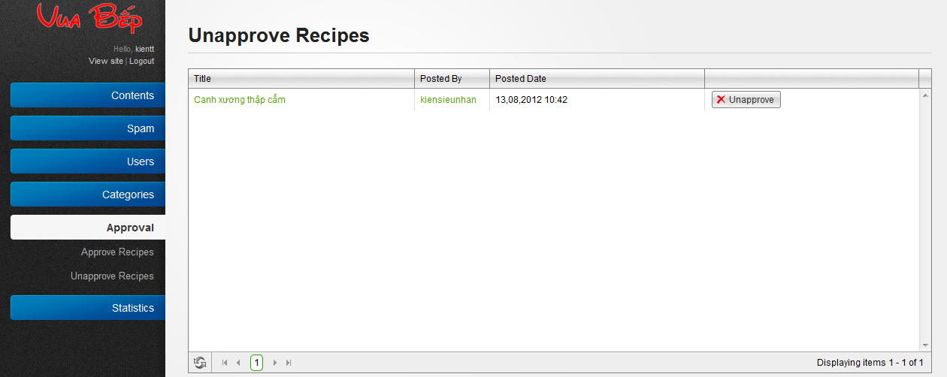**

* + Click to “Unapprove” button to unapproved recipe.

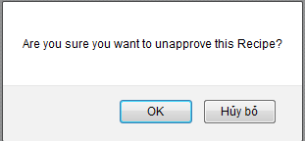

* + Click “Ok” button to complete action or “Hủy bỏ” button to dismiss.

## Dictionary

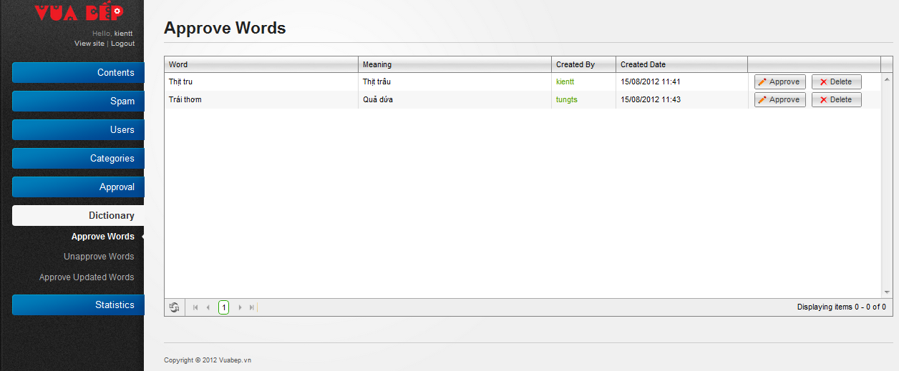

* Click to “Approve” button to approve a word

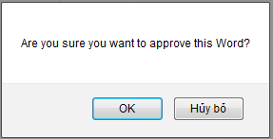

* + Click to “OK” button to complete action or “Hủy bỏ” to dismiss
* Click to “Delete” to delete word.

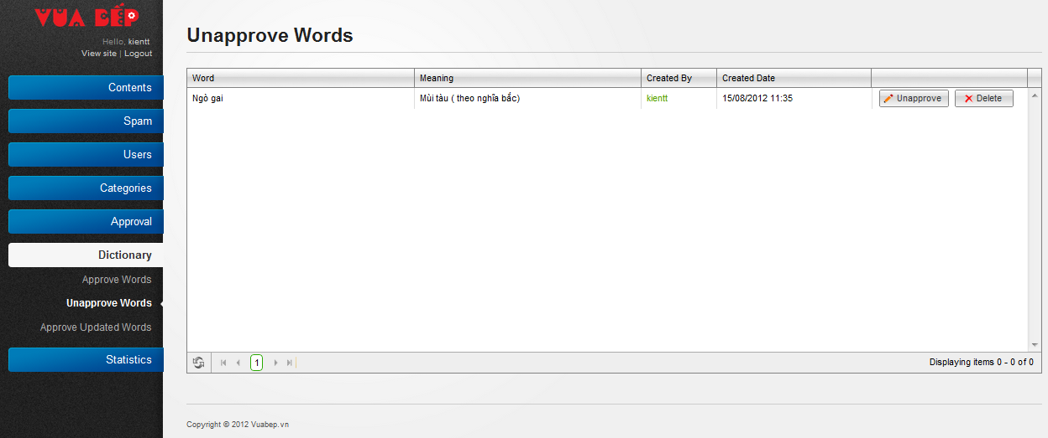

* Click to “Unapprove” button to unapproved word.

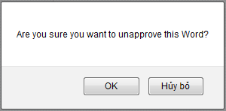

* + Click “Ok” button to complete action or “Hủy bỏ” button to dismiss
* Click to “Delete” to delete word.

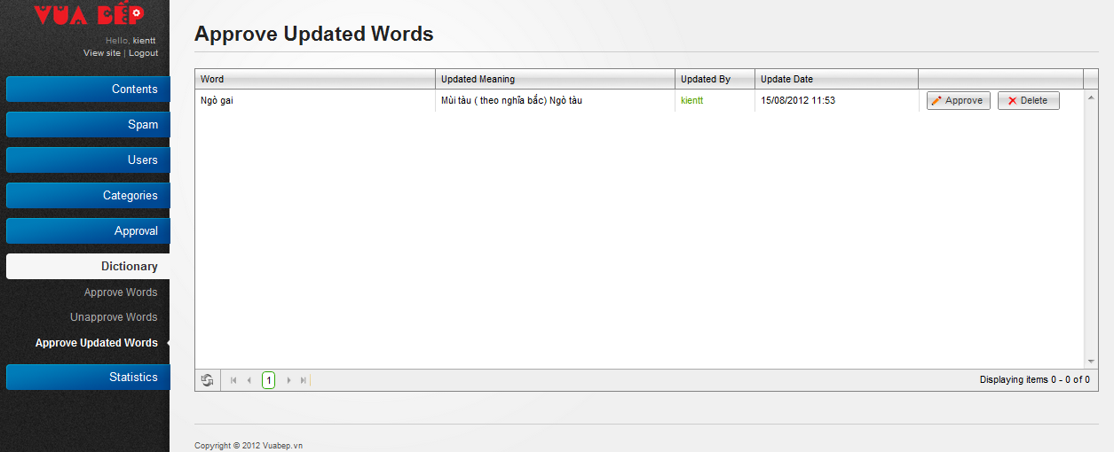

* Click to “Approve” button to approve an update word



* + Click to “OK” button to complete action or “Hủy bỏ” to dismiss
* Click to “Delete” to delete word.